SUMMIT ACADEMY OIC FINANCIAL AID CHECKLIST

Welcome to Summit Academy OIC!
This packet will give you the information needed to apply for financial aid.
- Go to https://studentaid.gov/fsa-id/create-account/launch?continueTo=fafsa Create an FSA ID and Password
If you do not have an email address, you’ll need to create an account. Example: Gmail, Hotmail, Yahoo. *Remember your email address and password.
- Go to https://studentaid.gov/h/apply-for-aid/fafsa complete the 2022-2023 FAFSA
SUMMIT ACADEMY OIC SCHOOL CODE: 015950
Degree or Certificate you will be working on: Certificate/Diploma – Less than 2 years
*Do not list “Graduate/Professional.”
•Call 1-800-433-3243 with any questions that come up as you’re completing your FAFSA
- Schedule your Financial Aid Appointment- Once your fafsa arrives on campus (3-4 days after submitted) you’ll receive an email with an online calendar invite from:

Carol Barta (last names A-L)
or
Koua Her (last names M-Z)

You’ll be able to select the date and time you’d like to meet with them.
MY FINANCIAL AID APPOINTMENT DATE AND TIME: ______________________
- Bring your photo ID and Social Security card if you did not attach them to your admissions packet and any other requested documents to Financial Aid Appointment.

Setting up your FSA ID
If you have a PIN or Personal Identification Number that you used to complete a FAFSA in the past, it is no longer a valid way to complete your Free Application for Federal Student Aid. The Department of Education has moved to a process that includes an FSA ID Username and password.

HOW TO CREATE YOUR PERSONAL FSA ID:
- Go to www.fafsa.ed.gov. Click “Start a New FAFSA.”
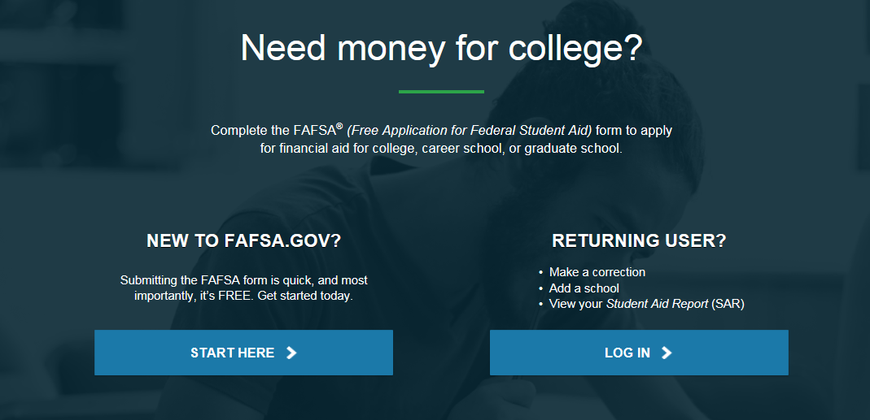

- If you are the student, click “I am the Student”
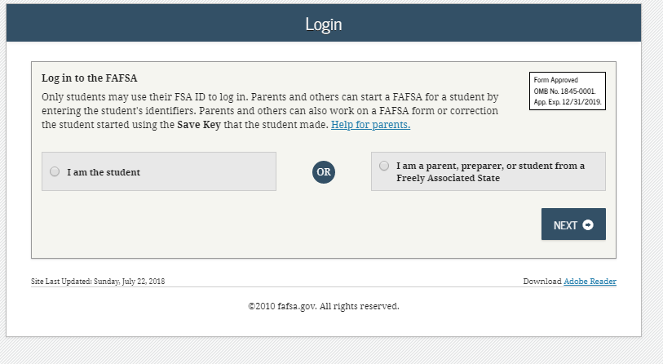

- Click “Create one.”
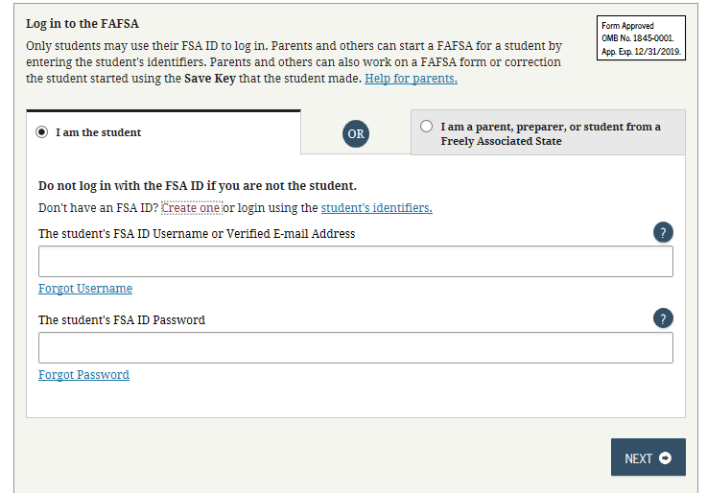

- The “Create a New FSA ID” page will load. Enter your email, and create a Username and Password.
*Note your user name must be between 6 and 30 characters. Please choose a username you will be able to remember in the future.
*The password must be:
** Between 8 and 30 characters
** Contain uppercase letters, lowercase letters, numbers, and a special character: ! @ # $ & * ( ) [ ] _ - ?.
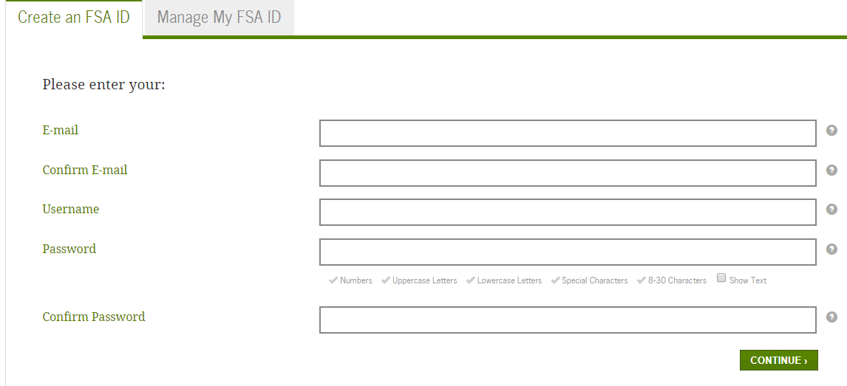
Once you’ve created your Username and Password, click “Continue.”
WRITE YOUR USERNAME AND PASSWORD IN A SECURE, CONFIDENTIAL LOCATION!

- Once you have successfully created your Username and Password, you’ll be directed to enter in personal Identification Information that includes your Social Security Number, Date of Birth, and Full Name. Enter information and click “Continue.”
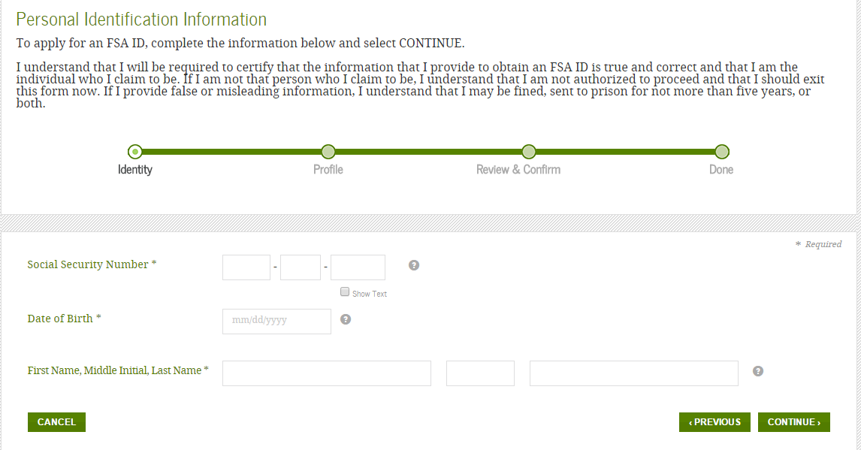

- The next page will ask you to complete information on your Mailing Address, Phone, and Language Preference. Enter this information and click “Continue.”
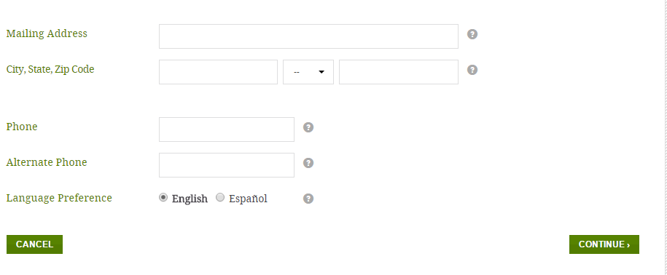

- Select two challenge questions. Then create two challenge questions. Click “Continue.”
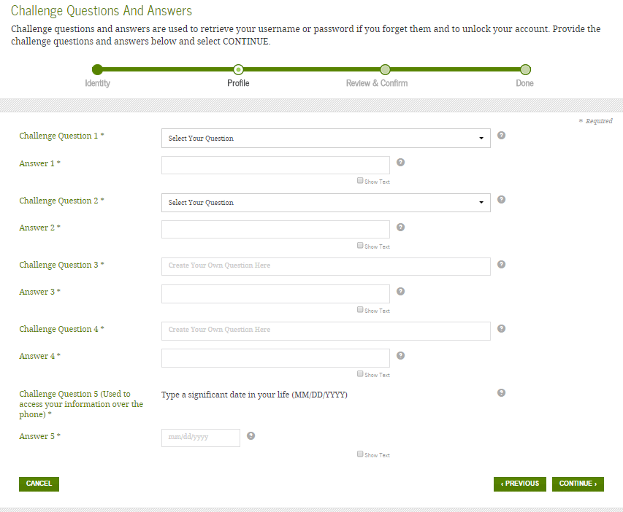

- You’ll be asked to review your information and confirm its correctness. Please proof read your information, and read the agreement on the bottom of the page. By clicking the “I certify that the above information is correct & accept the terms & conditions” you are confirming your information to the Department of Education. Click the agreement box, and then click “Continue.”
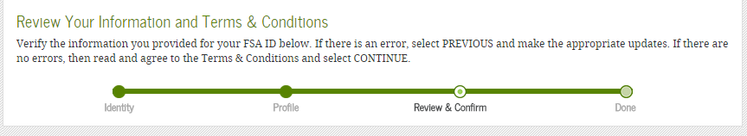
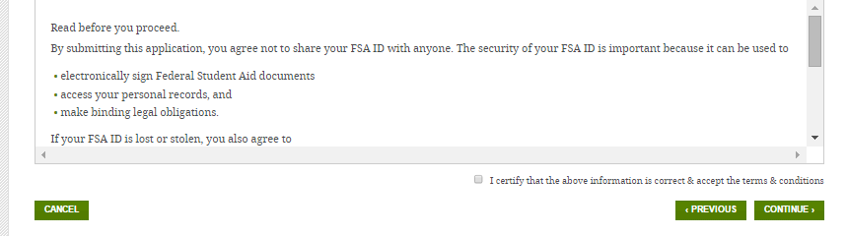
- You’ll be asked to sign into your email to obtain a verification code sent to you from the Department of Education. You will need to verify your FSA ID through this process. Please log into your email and find the verification code. Enter this code into the “Secure Code” box and click “Continue.”
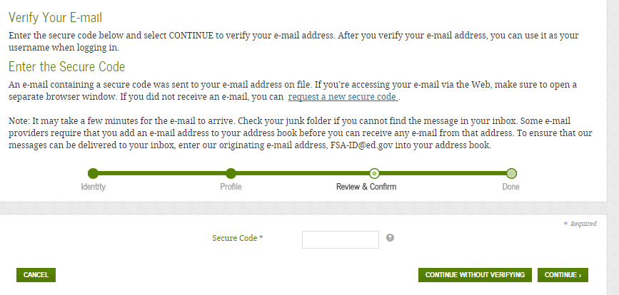
- Once you’ve verified your FSA ID, you’re ready to begin the FAFSA. You will use this FSA ID to access the FAFSA, as well as sign and submit your FAFSA. Please keep all information in a secure and confidential location.
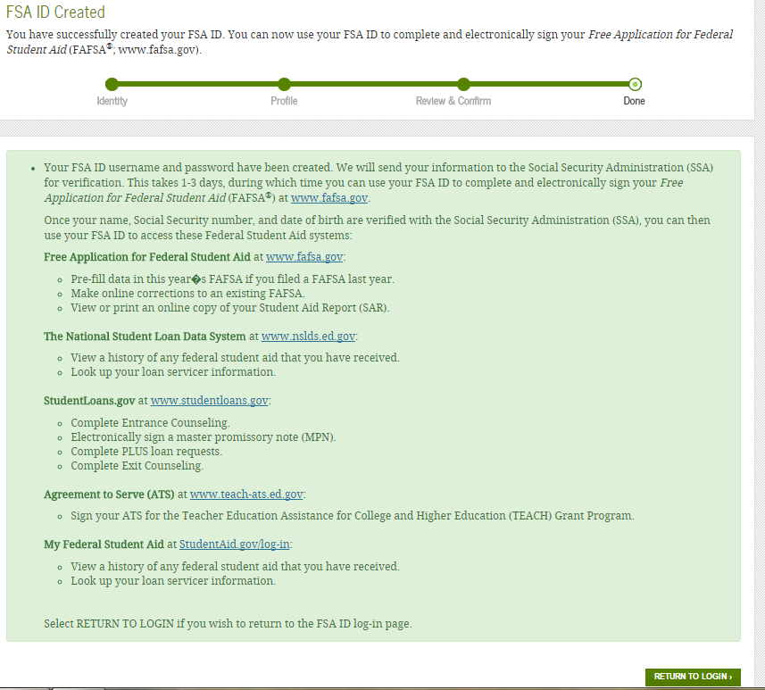

NOW YOU’RE READY TO COMPLETE YOUR FAFSA’s – FREE APPLICATION FOR FEDERAL STUDENT AID!
** Return to www.fafsa.ed.gov, enter your FSA ID Username and Password to begin the FAFSA.

ITEMS YOU’LL NEED TO COMPLETE FAFSA:

- Your Social Security Number
- Your Driver’s License Number (If you have one)
- Your 2020 W2s or 1099 forms. This will show how much income you’ve earned for that year.
- You (and your spouse’s) 2020 filed IRS 1040 tax document.
NOTE: If you didn’t file taxes or did not have any earned income in 2020, you must still complete the FAFSA.

If you did not earn any income, you can put “0” where applicable.

  - If you and/or your spouse filed taxes, you will also have the option to link your tax information to the FAFSA using the IRS Data Retrieval Tool. Please see instructions for this process below.
- If you are under the age of 24, you MUST provide Federal Income Tax information for your parent, unless the FAFSA gives you the option to exclude parental information. If you must provide parental information, your parent(s) can also utilize the IRS Data Retrieval Tool to link the taxes to the FAFSA.

HOW TO LINK FEDERAL TAX INFORMATION TO THE FAFSA
Linking Federal Tax Information to your FAFSA is a quick way to get the necessary information transferred. If you are unable to complete the linking process, don’t worry! Typing the information from your Federal Income Taxes is also acceptable.
- When you reach the point of the FAFSA where you are asked for Federal Tax Information, you’ll be asked questions to determine if the option to link tax information to the FAFSA is available. If you are eligible to use it, a button to “LINK TO IRS” will appear. Click this link.
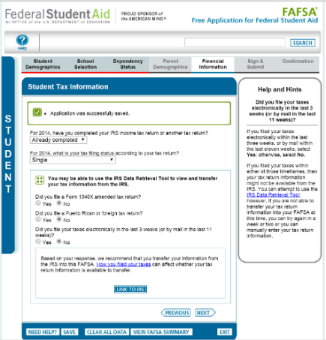
- The FAFSA will direct you to the page describing the process of linking the Federal Income Taxes to the FAFSA. Click “OK”
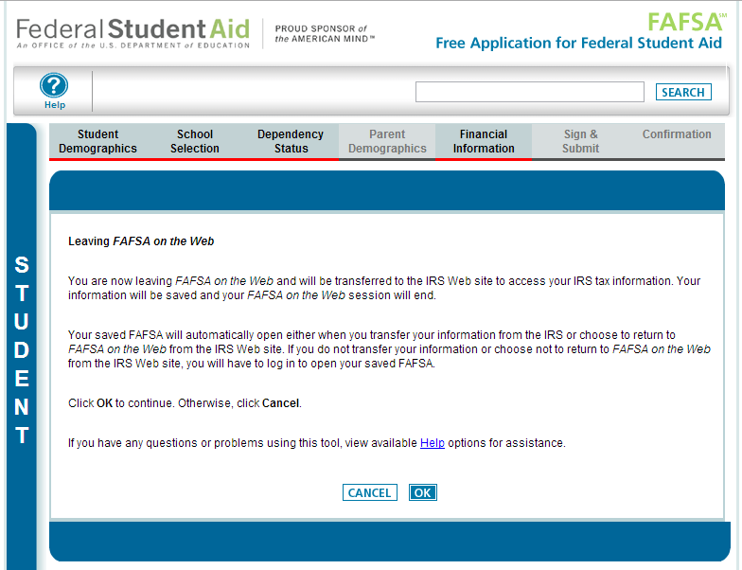

- You will need to authorize using this tool by clicking “OK” on the pop-up.
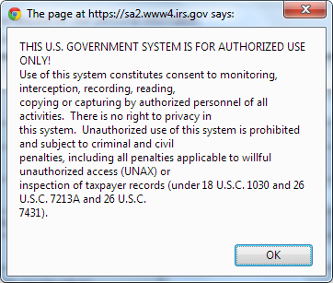
- Enter in your name and address EXACTLY as it appears on your 2019 Federal Tax form. This includes correctly typing your address.
Example: Type 215 Elm Street, if that is how it is listed on your taxes, versus 215 Elm St.
Once the information is entered, click “Submit.”
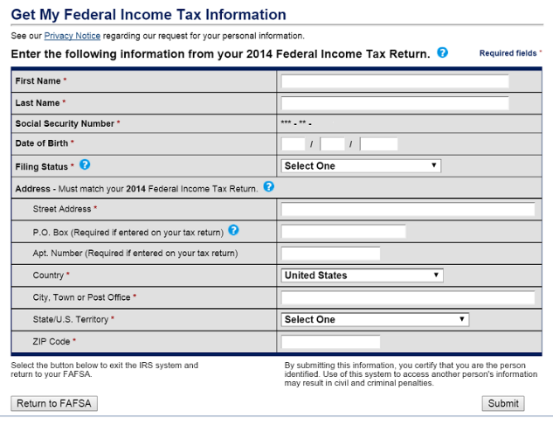
- If the information entered has the ability to be transferred, you’ll be directed to the transferring page. Click the box “Transfer my tax information to the FAFSA,” and then the “Transfer” button.
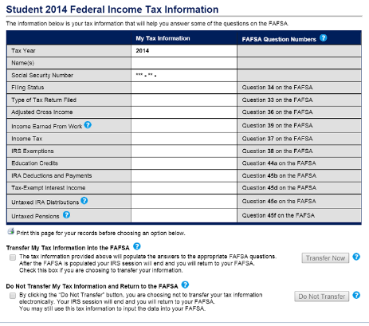
- If the transfer was successful, you will be directed back to the FAFSA and you will see the confirmation at the top of the page.
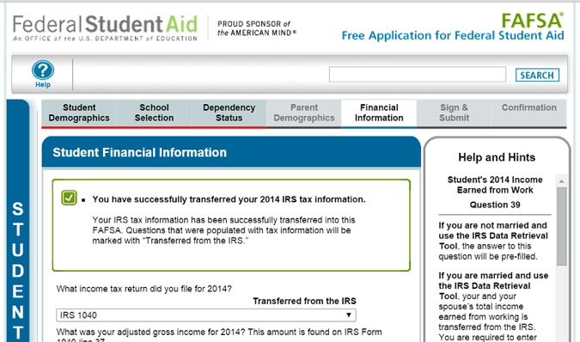

NOTE: If you are using the IRS Data Retrieval Tool for both the student and parent you will have to complete this process twice, once under the Student Financial Information Section and once under the Parent Financial Information section before submitting the FAFSA.

- Continue to the “Sign & Submit” Page. Enter your FSA ID and Password, then click the SIGN button. Next, click “Submit My FAFSA Now.”

**IF YOU HAVE QUESTIONS AS YOU’RE COMPLETING YOUR FAFSA PLEASE CALL 1-800-4-FED-AID**

